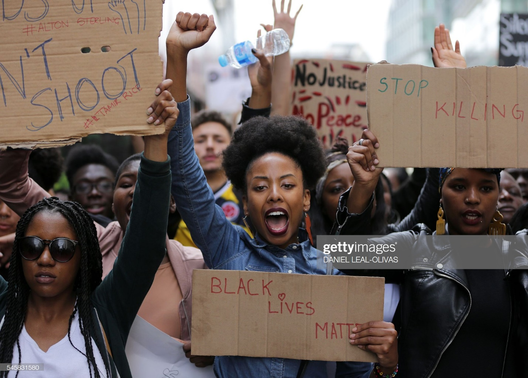

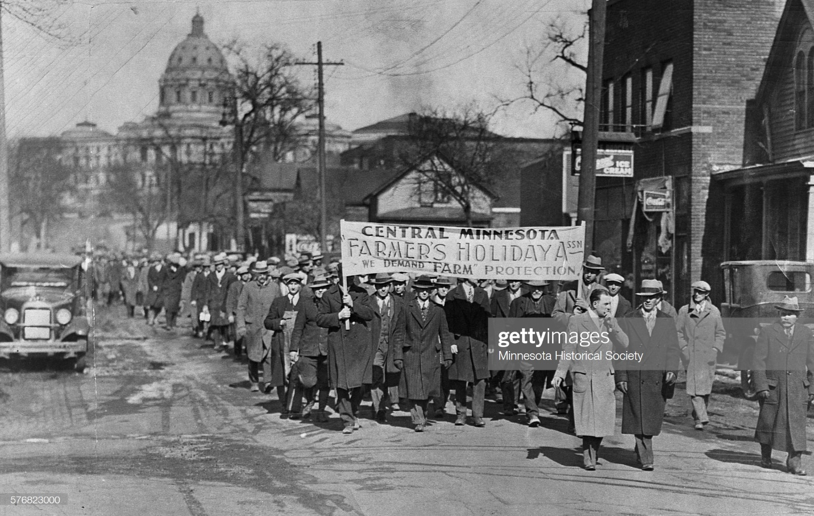

COM 323: Theory and Research in Small Group Communication

(Sections 001 and 002; Fall 2019)
M/W/F: 11am-11:50am (Fell Hall Rm 152) & 1pm-1:50pm (Fell Hall Rm 148)
Office Hours: M/W 8:00am-10:00am (Fell Hall Rm 458)
Professor: Byron B Craig, PhD

Required Materials
- Course readings are located on Reggienet.
- Access to a computer, tablet, or smart phone.
- Pen and Paper for notetaking (I will supply PowerPoints from class lectures and you should print these out and bring to class)

Course Description

This course will examine both theoretical and experimental literature dealing with Small Group communication processes. Groups such as “Moms Demand Action: For Gun Sense in America,” “Black Lives Matter,” “#MeToo,” “#BlackGirlMagic,” “The Beyhive,” “Doctors Without Borders,” and “Mothers Against Drunk Driving” all started with a small group of citizens coming together for a common cause—be it gun safety, protesting police brutality, worshipping celebrities, fighting gender inequality and sexual assault, fighting for the environment, or fighting for regulations to prohibit teenage drunk driving. As we can see, small groups and small group communication can be thought of as a response to our current/contemporary rhetorical situation and/or condition. More to the point, this semester we will examine Small Group Culture (SGC) as a response to several current crises as we deal with both social and cultural polarization.

This leaves us with several critical questions including: How do Small Groups begin? Why are they an important part of what makes up a rhetorical culture? When are Small Groups most successful, and conversely, does the group identity they evoke have a dark side? Small groups emerge when an incident, issue, or exigence happens that make a group of people come together to create change. In both images, above, small groups of people came together to address 1) the excessive policing of pedestrians and 2) the difficulty of farming and the unfair treatment of farmers in the United States. Small groups also form when people come together to form social cliques, clubs, committees, social and/or Greek organizations or small companies. Whatever the reason, when groups come together, they do so to address some problem and to find a way to create change that improves the conditions of their group or that of the larger public culture.

To address these questions and more, we will proceed as follows:

Unit One: Define and describe small group communication
Unit Two: Making sense of the rhetorical culture in the formation of small group
Unit Three: Social movement and social change in small groups
Unit Four: The dark side of small group communication and group identity

This semester, we will 1) examine the rhetorical culture of small groups, 2) locate some of the rhetorical exigencies that create small groups, 3) consider the role small groups play in creating social change and 4) explore the dark side of small group and small group rhetoric/identity, (i.e., demagoguery, scapegoating, and the breakdown of communication norms for a democratic culture)

Course Objectives

This semester we will look at the theoretical and experimental processes of groups to explore some of the larger implications of small group communication. We will examine a variety topics to help us think about the implication small group communication theory has on the public culture. This includes, but is not limited to:

- The way small groups effectively come together and create change that shapes who and we are and how we engage one another and specific circumstances in our contemporary age
- Small group reliance on effective communication, and the intersection of theory and praxis
- Focusing on the reasonable responses and outcomes of small group work that tend to promote or justify involvement and calls to action
- The social and redeeming value of small groups and rhetoric used by and about small group activism and how, through democratic participation, we use the small group (and small group communication) to create effective argument and reasoning to challenge policy and make policy changes that affect the public culture
- Better understanding the possible dark sides small groups (e.g., tyranny, attack/assault by outsiders of the group, etc.) face when we fail to understand how demagoguery happens.

We will examine and define, small group as a rhetorical process that has the power to create change in our local, federal, and international relationships. To help us better understand how small group communication works, we will have readings, use other texts (such as film and television series), and class lectures to help us better define the small group as a rhetorical process.

My primary objective as an instructor is to do everything I can to create an atmosphere in which we can learn creatively, productively, and happily. Each member of this class contributes to that environment, and together we share the power to determine whether we achieve that goal. To that end, please do not hesitate to ask questions or to seek help, in or out of class.

This class fully supports ISU’s commitment to creating a working, learning and living environment that is welcoming, supportive, respectful, inclusive, diverse and free from discrimination and harassment.

Upon successful completion of this course, you should be able to:

- Identify and define different theories that address small group communication and rhetorical culture
- Critique and analyze different small group processes in the contemporary public culture
- Write an essay that supports an argument you have crafted over the course of our semester
- Clearly articulate your ideas and thoughts verbally, visually, and in writing.

Course Assignments
You will complete several assignments throughout the semester, including:

- An annotated bibliography based on your research over the semester
- Four short concept and/or theoretical framing essays
- Participating in and reporting on a Small group activity (for this semester, you will create and/or be a part of a virtual small group community that studies a local organization, a political organization, or an activist organization/group and how it uses social media)
- Create and deliver a poster-board session with a small group of your class peers that defines a theoretical and experimental process
- Present your final essay research
- Write a final essay that combines your annotated bibliography and your short theoretical and experimental essays

*Short Essay One:
For short essay one, you will choose a theme from the film and one theoretical perspective we have read about and discussed in class and write a 3-4-page essay. Your essay should 1) offer a rhetorical analysis of the rhetorical exigency and 2) describe the small group as a rhetorical culture. (50 points)

*Short Essay Two:
In short essay two, you will pick a social movement that originated from a small group of citizens coming together. In the 3-4-page essay please address how the small group formed and what small group rhetorical strategies were used to advance their cause. You should use the readings from the second unit to support your argument and any additional literature you find to describe the goals and shortfalls of the small group’s growth to social activism. (50 points)

*Short Essay Three:
For this 2-4-page essay, please describe and place into conversations, at least two theoretical and at least one experimental perspective by thinking about how the authors/scholars would talk about their different approaches. How would the scholars define their approaches to small group processes? How would they say they differ? Which approach would you say works best for the topic you described in short essay two? Why? Again, you are expected to facilitate your essay using the essays used for this class and more as needed. (100 points)

*Short Essay Four:
For your final short essay (3-4 pages) you will provide an analysis of one of the themes from Roberts-Miller’s Demagoguery and Democracy. In this essay, you will use one or two relevant and current examples to support your analysis of the dark side of small group rhetorical culture. (100 points)

*Semester Essay:
In your final 10-15-page essay you will find a way to bring all four short essays together using additional scholarship on small group rhetorical culture to create an argument that supports your understanding of small groups after looking at several theoretical perspectives this semester. (200 points)

*Annotated Bibliography:
To help you with your final semester essay, you will create an annotated bibliography that identifies and defines several scholarly resources. For each source that you identify you will write a brief (one to two sentence) synopsis of the essay and a brief (one to four sentence) synopsis describing why the source is helpful toward the composition of your final essay. (200 points)

*Poster Session:
In teams, you will create a poster that visually explains your teams’ semester research on how small groups function when operating vis-à-vis social media. You will be provided with specific instructions for this assignment. (100 points)

*Team Social Media and Small Group Culture:
In teams, you will study and then create an online small group that addresses some important issue you have identified in the public culture (e.g., environmental, political, gender/racial/socio-economic class issues). (100 points)

*Semester Paper Presentation:
On scheduled days, you will present your semester research essay to your classmates. You will talk about the exigency, the response to the exigency, how understanding small group theory helps us to better understand those responses, and finally, why it is important to understand how small group theory is a critical function in our current public culture. Your classmates will offer valuable feedback as you explain your scholarly research. (100 points)

You will receive a sheet that explains the expectations for each assignment. Additionally, I will include a grading rubric for your use prior to turning in each assignment.

Course Grades

990-900 points 99% - 90% A 790-700 points 79% - 70% C 590-500 59% - F
890-800 points 89% - 80% B 690-600 points 69% - 60% D

Course Policies and Rules

LAPTOPS AND OTHER ELECTRONIC DEVICES

When in class, students should be engaged with the discussion. To this end, cell phones and other devices should be turned off. Please unplug!!
Note that the most efficient way to take notes is NOT by laptop, and the use of computers to surreptitiously surf the Web during class seriously impairs your ability to learn. Consequently the use of laptops in class is not recommended, although they may be used for the sole purpose of taking down notes offered on the board at the beginning of each class. Ten minutes will be allowed for this, after which time laptops must be closed and notes then taken by pen and paper for the remainder of the class. The use of cameras and other recording devices in class is strictly prohibited, as is the use of Google Glass.

ACADEMIC INTEGRITY

Students are expected to accomplish their own work and submit work that is original for this class. All students are also responsible for reading and understanding the university’s position on academic integrity as outlined in the ISU Student Code of Conduct as found in the Student Handbook, Policy IIIB. It is not acceptable to claim “I didn’t know it was plagiarism” or “I didn’t know plagiarism was prohibited” as a defense. If a breach of academic integrity is discovered, I will assign a penalty appropriate to the severity of the offense. Such penalties may include: completing the assignment again, a point penalty on the assignment, a score of zero on the assignment, failing the entire course, and/or reporting the incident to Community Rights and Responsibilities for resolution at the university level.

ASSISTANCE

Students who are having difficulty with readings, class material or assignments are encouraged to talk to me at the earliest opportunity. Time will be set aside in class for question and answer sessions, and I will be available to discuss questions or difficulties either after class, during office hours or by e-mail. If you’re feeling stressed, overwhelmed, lost, anxious, depressed or are struggling with personal issues, do not hesitate to call or visit Student Counseling Services (SCS). These services are free and completely confidential. SCS is located at 320 Student Services Building, 309-438-3655.

Any student needing to arrange a reasonable accommodation for a documented disability and/or medical/mental health condition should contact Student Access and Accommodation Services at 350 Fell Hall, (309) 438-5853, or visit the website at StudentAccess.IllinoisState.edu.

Attendance, Participation, and Professionalism Policy:

Attendance is required in this course and will be calculated as part of your final grade. I will use a “roll sheet” which I will pass around at the beginning of class. The only acceptable proof of your attendance is your signature on the “roll sheet.” If you arrive to class late, it is your responsibility to find and sign the roll sheet. I expect you to arrive to class on time and to leave class only when it concludes. Your failure to do so reflects negatively on your professionalism, which in turn affects your participation score in this class. If you must miss class, I always appreciate being informed beforehand. Although notifying me in advance does not excuse your absence, it is common courtesy.

Assignment Due Dates:

All assignments are due at the specified time. For essays and the annotated bibliography, all work will be turned in online. I will always set the due date (in writing) for 11:59pm. However, I will always allow a two-hour window meaning your work will be due by 2:00am in the appropriate folder. Failure to turn in all work on time will result in a deduction of your assignments final grade. Failure to turn in work will result in a zero for that assignment. I will not accept late work without prior knowledge that you have an excuse I say is acceptable. That discussion must happen well in advance of the due date (at least 48 hours in advance) Failure to discuss this with your professor will result in a zero on your assignment.

Grading Policy:

Please the grade scale below. I will not round up grades at the end of the semester. It is your responsibility to meet with me if your grade is not what you hoped. You should be proactive. For example, if you receive a grade lower than anticipated on your first short essay, please see me for more direct assistance (I can offer more substantive assistant during office hours). I am more than happy to help you, however, if you fail to seek assistance, I cannot assist you in gaining a higher grade.

Additionally, if you have a grade dispute, please feel free to come to office hours so that I can explain my rationale. I will always offer a grading rubric for all assignments. It is your responsibility to examine the rubric and ask for clarification if needed.

Finally, if you have an issue with a grade, I will not respond to demanding language or language I find insulting. As I will show respect to you in the classroom, I expect the same behavior from you.

Course Calendar

Week One: Course Introduction to Syllabus and Semester Plan
8/19: Introduction to course and begin watching Mean Girls
8/21: Continue watching Mean Girls
8/23: Read, “Group Identity is All” by Amy Chua from Foreign Affairs July/August 2018; Finish watching Mean Girls and discussion of Small Group as rhetorical formation

Weeks Two: What is Small Group Communication
8/26: (Weekly Overview); Discussion: Read Erving Goffman’s The Presentation of Self in Everyday Life chapter 1

8/28: Discussion: Continue reading Goffman, chapter 2 and discussion
8/30: Class discussion and introduction to semester Group Project (bring one reading on social media and social change for your team’s discussion)

Week Three: Introduction to Small Group Communication and Theories of Social Change
9/2: No class; Labor Day Holiday
9/4: (Weekly Overview); Read Introduction & discuss Asen and Brouwer’s Counterpublics and the State
9/6: Read pgs. 87-110 and discuss Asen and Brouwer’s Counterpublics and the State (or documentary); Short essay one is due by 11:59pm

Week Four: Small Group and Theories of Social Change
9/9: (Weekly Overview); Read pgs. 111-136 and discuss Asen and Brouwer’s Counterpublics and the State
9/11: Read pgs. 161-186 & discuss Asen and Brouwer’s Counterpublics and the State
9/13: Read pgs. 187-210 & discuss Asen and Brouwer’s Counterpublics and the State

Week Five: Small Group and Theories of Social Change
9/16: (Weekly Overview); Watch in class, Finding Justice
9/18: Watch in class, Finding Justice
9/20: Class Discussion on episodes and Asen and Brouwer

Week Six: Small Group and Theories of Social Change
9/23: Class will not meet today; Work on team projects
9/25: (Weekly Overview); Watch in class, Finding Justice
9/27: Class Discussion on Asen and Brouwer; Short essay two is due by 11:59pm
Week Seven: Small Group and Theories of Social Change

9/30: (Weekly Overview); Watch Finding Justice
10/2: Watch Finding Justice
10/4: Finish discussion on Small Group and Theories of Social Change; Introduction to The Dark Side of Small Groups

Week Eight: Introduction to The Dark Side of Small Groups and Group Identity
10/7: (Weekly Overview); Read and discuss pgs. 1-20 (introduction and democratic deliberation) of Demagoguery and Democracy
10/9: Read and discuss pgs. 21-31 (the dark side of democracy) of Demagoguery and Democracy
10/11: Read and discuss pgs. 32-65 (Defining demagoguery) of Demagoguery and Democracy; Short essay three is due by 11:59pm

Week Nine: The Dark Side of Small Groups
10/14: (Weekly Overview); “Darkness and the Other” Read Burke’s “The Rhetoric of Hitler’s Battle” and watch “The Shelter” from The Twilight Zone
10/16: Read and discuss pgs. 57-96 from Mark Lilla’s The Once and Future Liberal: After Identity Politics
10/18: Discussion: Readings (Burke and Lilla) (Draft of Annotated Bibliography is due by 11:59pm)

Week Ten: The Dark Side of Small Groups
10/21: (Weekly Overview); Read pgs. 135-206 of Hochschild’s Strangers in Their Own Land and “Participation as a Pastime: Political Discussion in a Queer Community Online” by Svensson (2015); Discussion: Race, Sexuality and Polarization
10/23: Socio-economic Class and Polarization; Continue reading Hochschild
10/25: Watch episode of Black Mirror in class; Short essay four is due by 11:59pm

Week Eleven: The Dark Side of Small Groups
10/28: (Weekly Overview); Digitalization and Polarization; Continue reading Hochschild
10/30: Cyberbullying and the Social Network; Read “Student Cyberbullying Inside the Digital Schoolhouse Gate…” by Primack and Johnson (2017)
11/01: Stigma and Small Group culture; Return to Goffman and Mean Girls

Week Twelve: Small Group Presentations
11/4: Small Group Process Presentations (Social Change & Social Media)

11/6: Small Group Process Presentations (Social Change & Social Media)
11/8: Small Group Process Presentations (Social Change & Social Media)

Week Thirteen: Small Group Presentations
11/11: Complete Small Group Presentations and/or Work Day for final essays and Poster Boards
11/13: (Professor away for conference); Work on Annotated Bibliography Final Draft
11/15: (Professor away for conference) (Final Draft of Annotated Bibliography due by 11:59pm)

Week Fourteen: Presentation of Poster Boards
11/18: (Weekly Overview); Concluding comments; Redefining the Small Group for the 21st Century; a conversation for small groups

11/20: Concluding comments; Redefining social movement and the dark side of the Small Group in the 21st Century
11/22: Final work day for Research Presentations, Poster Board Sessions, Final essays

Week 15: November 23-December 1 (Week of Thanksgiving; no class meetings)

Week Sixteen:
12/2: Final Research Paper Presentations
12/4: Final Research Paper Presentations
12/6: Final Research Paper Presentations

Finals Week:
**On the day of your final, you will turn in your final essays during our designated scheduled final time**

